
PUCIT
Punjab University College of Information Technology

Group members:

Bilal Mubarak BSEF17M056
Maham Mubashir BSEF17M008
Anzala Mohsan BSEF17M018
Mubarra Naz BSEF14M031

Supervisor: Ma’am Madiha Khalid

Lahore Tour Guide
Second Deliverable

Table of Contents

1 Introduction 3
1.1 Usecase descriptions 3
1.2 Use Case Diagram (Refined) 12
1.3 Domain Model 12
1.4 Sequence Diagram 13
1.5 Collaboration Diagram 21
1.6 Operation Contracts 28
1.7 Design Class Diagram 31
1.8 Data Model 27

1 Introduction

Usecase Description

1.1.1 UC_Registration

Brief Description
To reserve any rooms, A user must have an account. So, in this use case the user will provide the required data. The system will perform validation checks where required if there is any invalid data the user will be asked to provide correct data. After the submission of data, the user will request to register. The system will enter the data into the database and a success message will be shown to the user.

Pre-conditions
The user must have internet connection

Basic Flow
- The user will provide required data and request to register.
- The system will validate the data and create an account for the user and display success message

Alternate Flow
- The user may want to cancel the request to create an account in this case it will end the use case
- The user may provide some invalid data in this case the user will be prompted to insert valid data and the normal flow of the user case will continue.

Post Conditions
An account for the user will be created and the user will be directed to home screen.

1.1.2 UC_Login

Brief Description
This use case describes how a user will log into the Lahore City Tour System. The actors starting this use case will be travelers and landlords.

Pre-conditions
The user must have internet connection and done registration earlier

Basic Flow
- The system will request the actor to enter his/her email and password.
- The actor will enter his/her email and password.
- The system will validate the actor’s password and logs him/her into the system and the use case ends.

Alternate Flow
- Invalid email / Password
- Return to login screen

Post Conditions
If successful, the user will be logged into the system and directed to the home screen If not the system state will remain unchanged.

1.1.3 UC_Search_by_location

Brief Description
User can find out all the nearby attractions places hotels restaurant just by turning ON his location services.

Pre-conditions
- User should have a strong internet connection.
- User should turn on his location.

Basic Flow
- User will open the application.
- Application will ask user to turn on his location if not turned on.
- List of all the nearby places will be shown.
- User will select a location
- Details of location will be shown.

Alternate Flow
Internet Connection fails.

Post Conditions
Application will successfully show all the nearby places getting location.

1.1.4 UC_Search_by_destination

Brief Description
User can search for all the prominent points of interest, and geographic locations and all the places just by entering a text string.

Pre-conditions
- User should have a strong internet connection.
- User should enter a valid string.

Basic Flow
- User will open the application.
- User will enter the name of a place in the search tab.
- List of all the nearby places will be shown.
- User will select a location from list
- Details of location will be shown

Alternate Flow
Internet Connection fails.

Post Conditions
Application will successfully show all the nearby places getting location.

1.1.5 UC_Get_Directions

Brief Description
This use case will help the user to get directions to the selected place using google map API.

Pre-conditions
The user must have internet connection.

Basic Flow
- The user will request the system to get direction of the selected place by clicking on it.
- The system will then redirect the user to google map and show him the direction.

Alternate Flow
None

Post Conditions
The map will show all possible directions to the place and the use case will end.

1.1.6 UC_Post_Rental_Ads

Brief Description
User (Landlord) will post an advertisement of the rentable room/apartment.

Pre-conditions
User must login

Basic Flow
- Click on add post button
- Fill the add posting form
- Add payment details
- Review the advertisement
- Open advertisement for public view

Alternate Flow
- The user has not logged in first, so move to login screen
- Some requirements left unfilled, prompt for filling in all fields.

Post Conditions
Advertisement posted successfully.

1.1.7 UC_Edit_Ads

Brief Description
Landlords who will add their post can edit details, change pictures, and switch availability i.e. they can label their advertisement as available or not available.

Pre-conditions
- Advertisement should be created
- User must login

Basic Flow
- User will review the advertisement
- User will select or deselect the availability option
- The advertisement will be labelled as available

Alternate Flow
none

Post Conditions
The advertisement will be updated.

1.1.8 UC_Delete_Ads

Brief Description
Landlords can delete their advertisement from the portal when they desire.

Pre-conditions
Advertisement should be posted

Basic Flow
- User will open the advertisement
- User will click the delete button
- Confirmation notification will be shown
- User will confirm deletion

Alternate Flow
Upon confirmation user doesn’t delete the advertisement

Post Conditions
Advertisement will be deleted.

1.1.9 UC_Search_apartment

Brief Description
The user will search the suitable room from the list of advertisements of rooms/apartments available.

Pre-conditions
User must login

Basic Flow
- Click on rentals button
- Look for the suitable room in the list
- Add filters to search easily
- Show details of the advertisement chosen to the user.

Alternate Flow
The user has not logged in first, so move to login screen.

Post Conditions
User gets all the details of the advertisement.

1.1.10 UC_Conversation

Brief Description
If the user will want to contact the landlord, he can start a conversation with the landlords of the place where he wants to live.

Pre-conditions
- User must login
- User must open an advertisement’s details.

Basic Flow
- Click the chat button
- Chat prompt will open
- User will type a message
- Send message to landlord
- Landlord will respond to message after receiving
- Chat will continue

Alternate Flow
User not logged in, prompt to login screen.

Post Conditions
Application will help in contacting with the place owners.

1.1.11 UC_Reserve_Apartment

Brief Description
User will find a suitable room/apartment and book it.

Pre-conditions
User should be logged in

Basic Flow
- Select booking option
- User will add payment details.
- User will confirm payment

Alternate Flow
If user will not be booking for the first time, he shall not need to add payment details.

Post Conditions
Application will book a room for User.

1.1.12 UC_Cancel_Reservation

Brief Description
This use case will allow the user to cancel the reservation.

Pre-conditions
- The user must have internet connection.
- The user must have made a reservation.

Basic Flow
- The user will request the system to cancel the reservation by clicking on the cancel reservation button available.
- The system will then delete the record of the reservation from the database reservation will be cancelled.
- A modal pop up will appear on the screen showing that the reservation is cancelled successfully, and the use case will end.

Alternate Flow
None

Post Conditions
The reservation will be cancelled successfully.

1.1.13 UC_Add_room_review

Brief Description
Whenever a user will reserve a room through our platform, he/she will be asked to add a review for the availed services so that the next person requesting the services may have an idea about the services provided by them.

Pre-conditions
- The user must be logged in.
- The user must have booked a room using our platform.

Basic Flow
- User will give rating from 1 to 5
- User will write a review

Alternate Flow
None

Post Conditions
The review will be posted.

1.1.14 UC_Add_Place_Review

Brief Description
The users will be allowed to post reviews for the places they have visited.

Pre-conditions
The user must be logged in.

Basic Flow
- User will give rating from 1 to 5
- User will write a review

Alternate Flow
None

Post Conditions
The review will be posted.

1.1.15 UC_Delete_Review

Brief Description
The users will be allowed to delete the review they posted.

Pre-conditions
The user must be logged in.

Basic Flow
- User will open the review
- User will select delete option
- User will confirm the changes

Alternate Flow
None

Post Conditions
The review will be deleted.

1.1.16 UC_Edit_Profile

Brief Description
The users will be allowed to edit their details e.g. name, contact, payment details, etc.

Pre-conditions
The user must be logged in.

Basic Flow
- User will open edit profile section
- User will edit the details
- User will confirm the changes

Alternate Flow
None

Post Conditions
The system will be updated

1.2 Usecase Diagram (refined and updated)

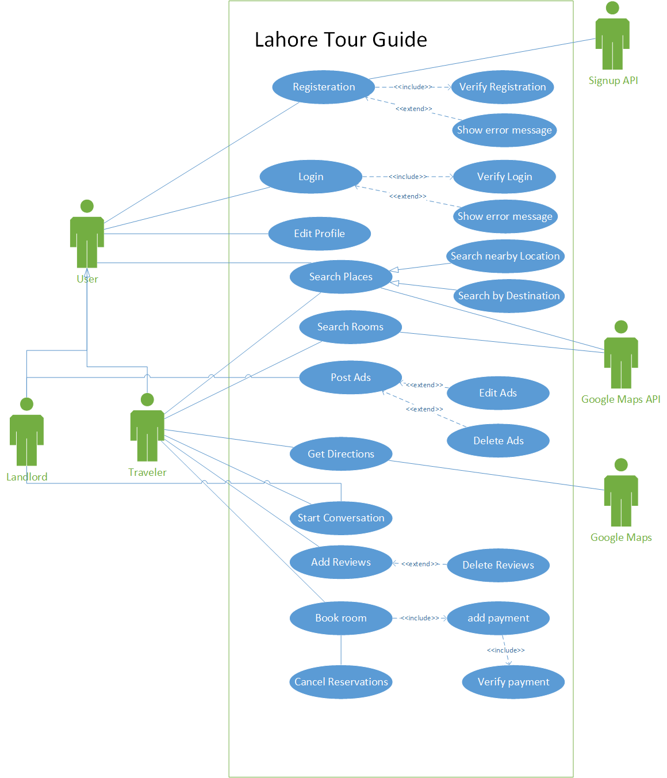

1.3 Domain Model
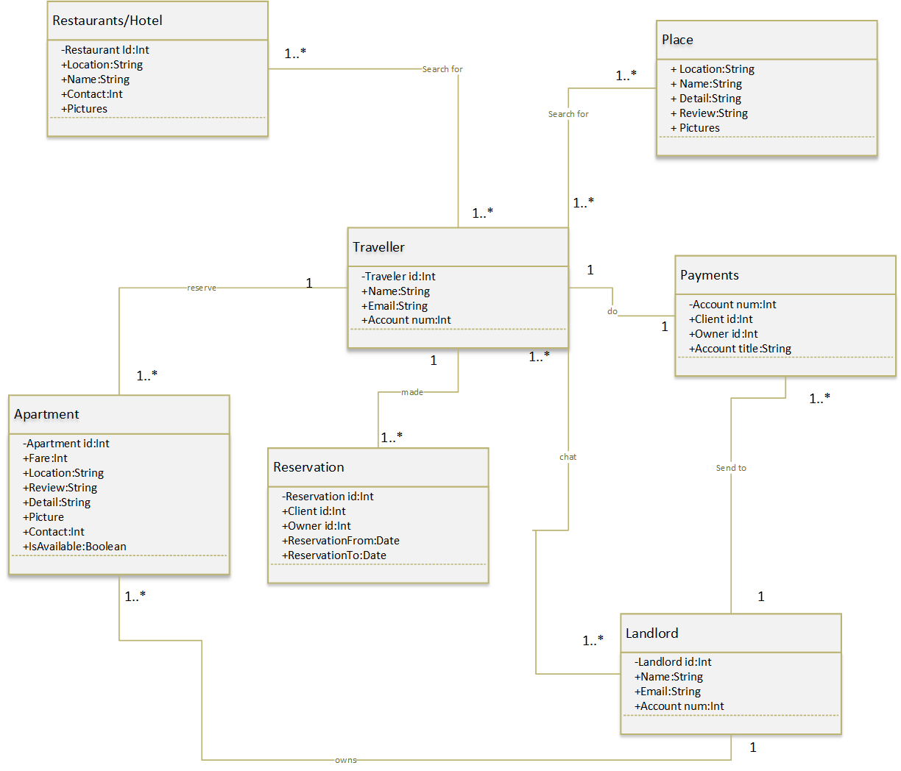

1.4 Sequence Diagram

1.4.1 UC_Registration

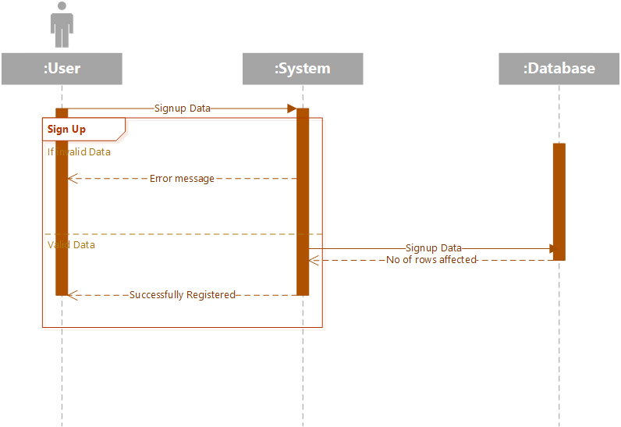

1.4.2 UC_Login

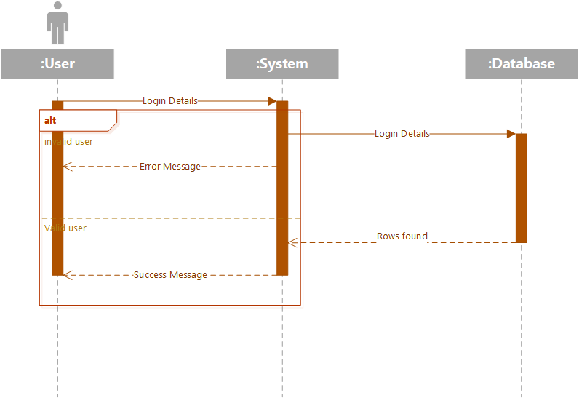

1.4.3 UC_Search_by_Location

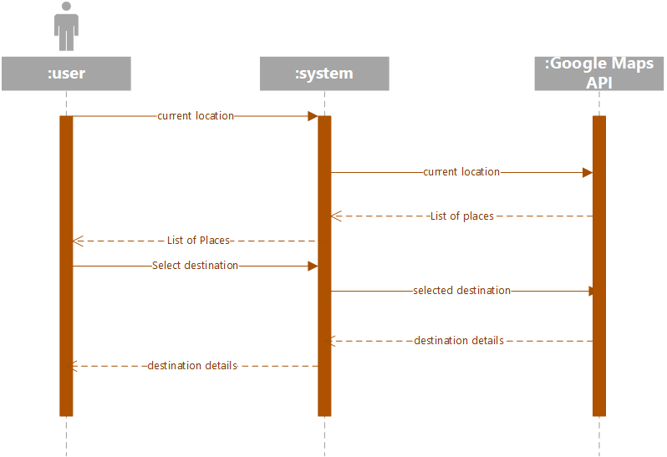

1.4.4 UC_Search_by_Destination

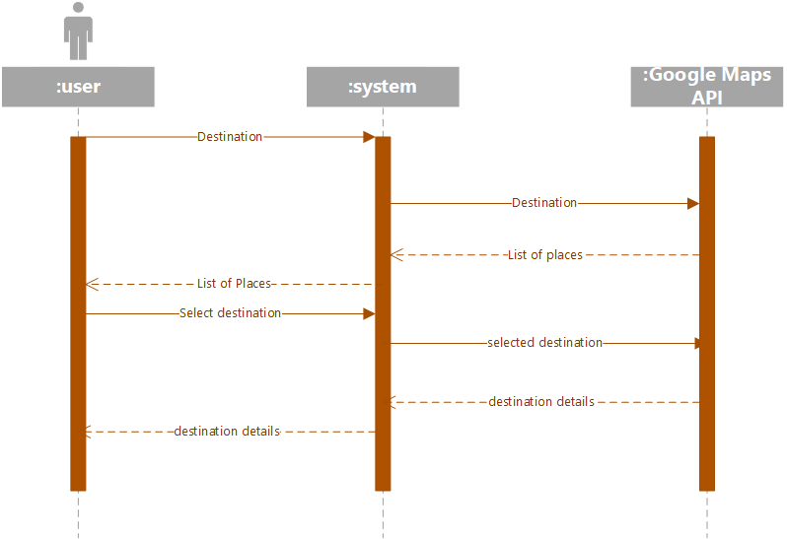

1.4.5 UC_Get_Directions

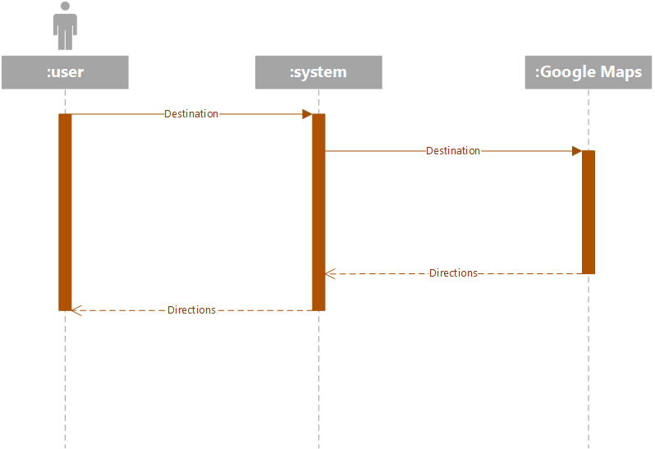

1.4.6 UC_Post_Rental_Ads

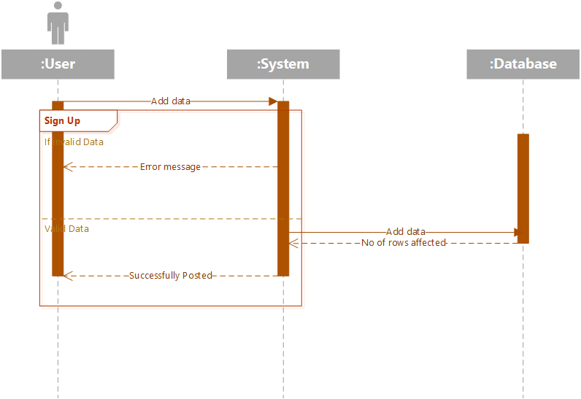

1.4.7 UC_Edit_Ads

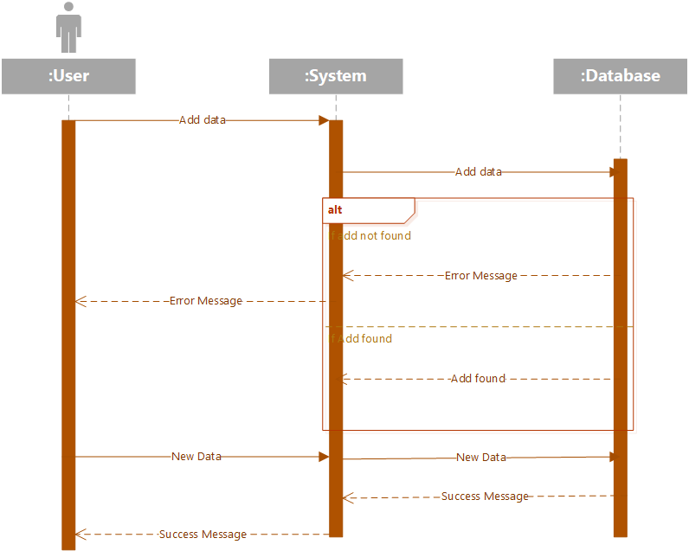

1.4.8 UC_Delete_Ads

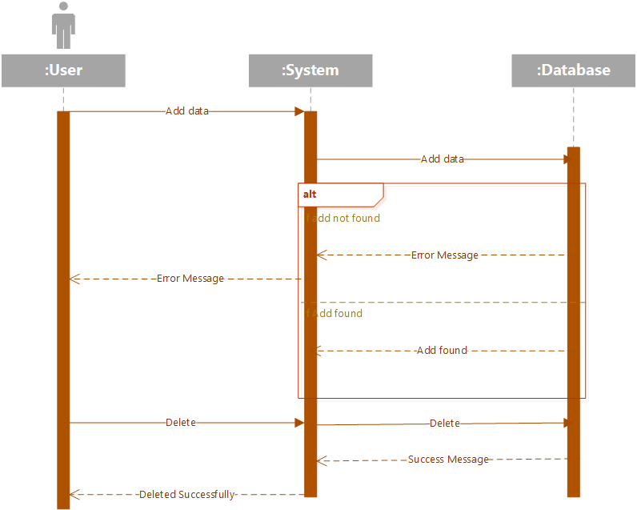

1.4.9 UC_Seacrh_Apartment

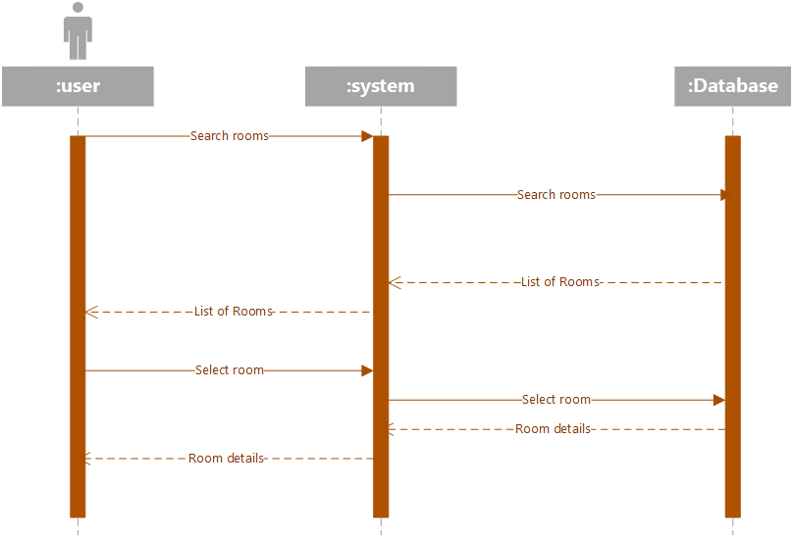

1.4.10 UC_Conversation

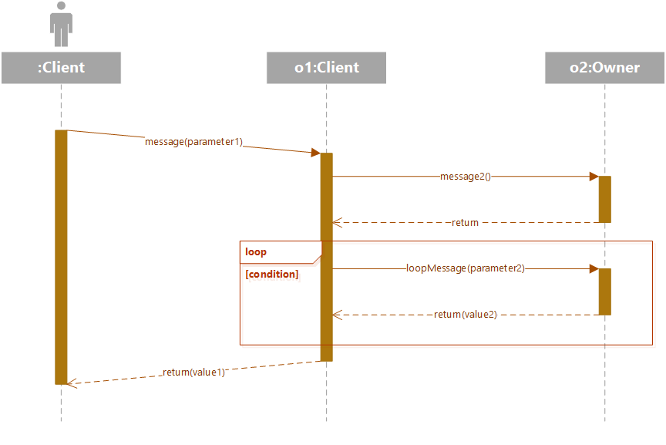

1.4.11 UC_Reserve_Apartment

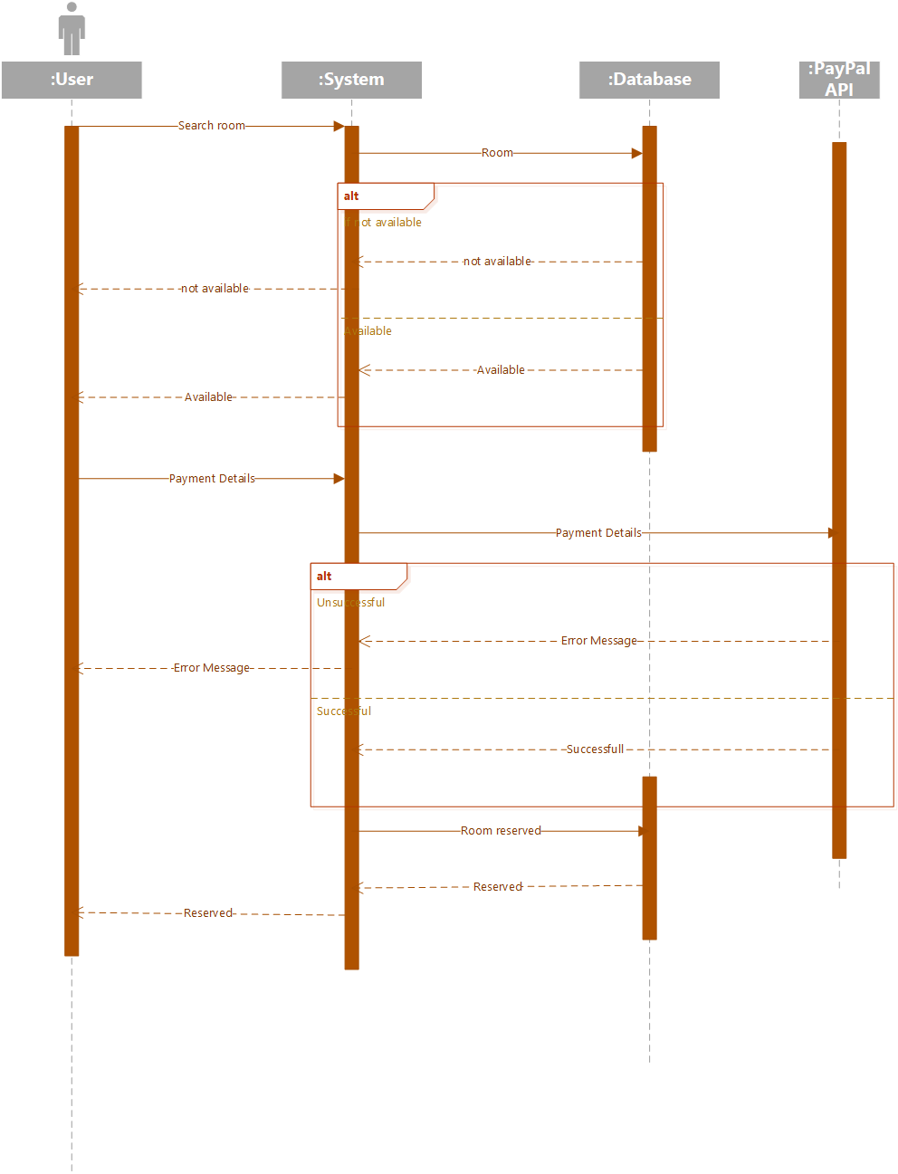

1.4.12 UC_Cancel_Reservation

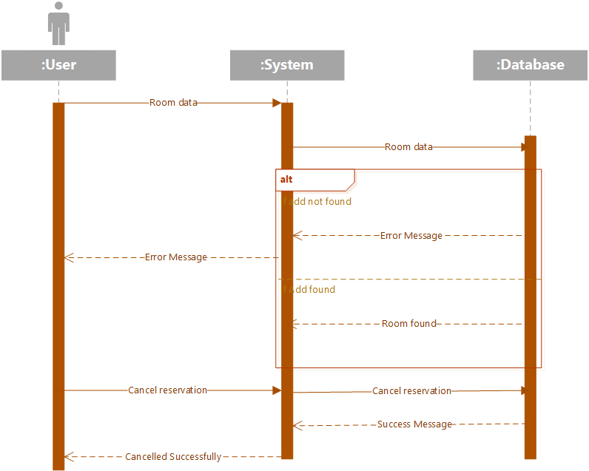

1.4.13 UC_Add_Review
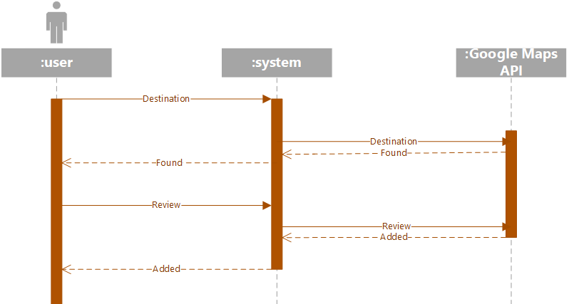

1.4.14 UC_Delete_Review

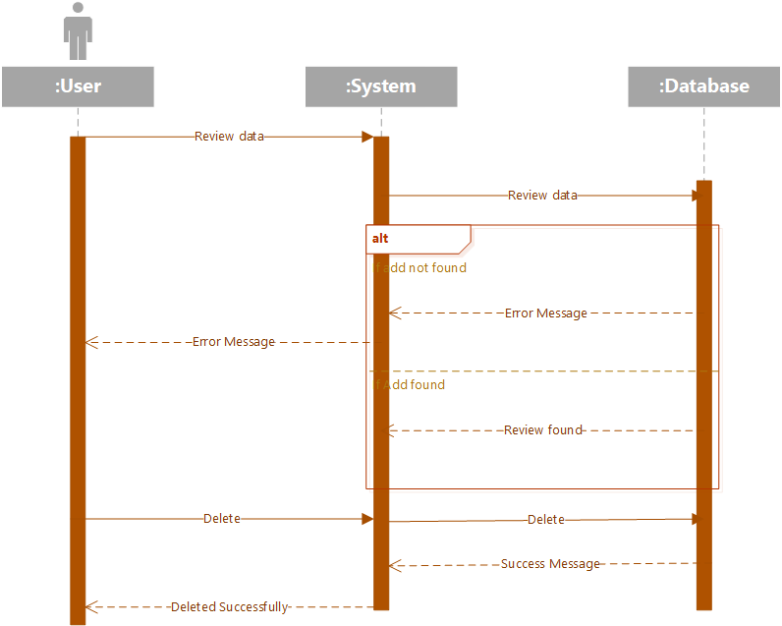

1.4.15 UC_Edit_Profile
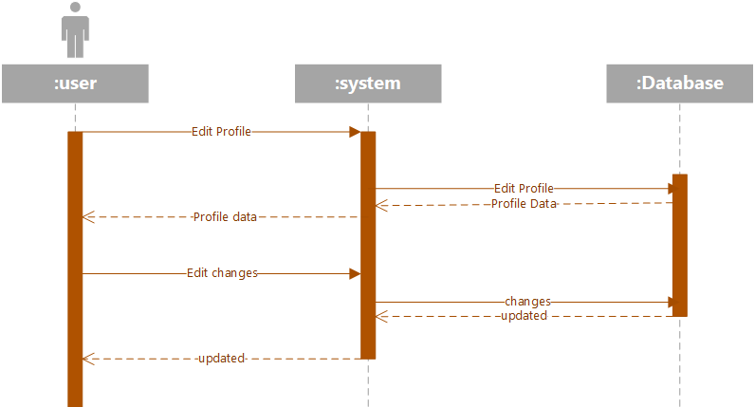

1.5 Collaboration Diagram

1.5.1 UC_Registration

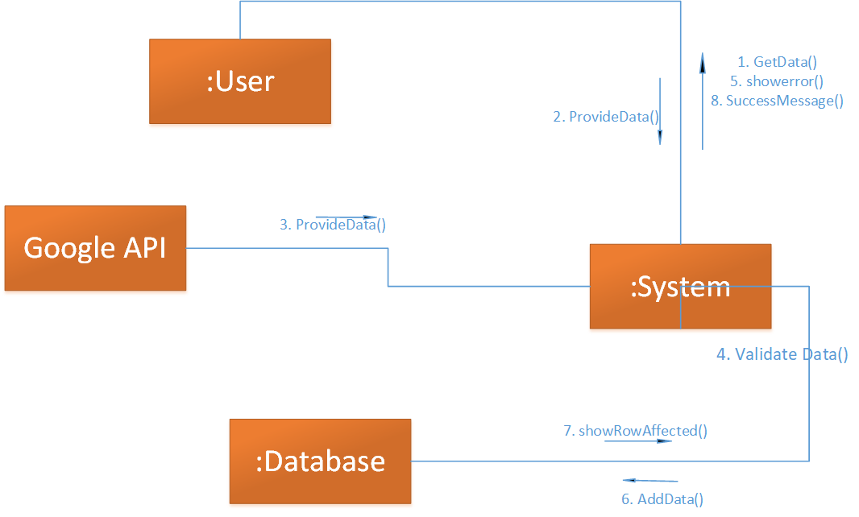

1.5.2 UC_Login

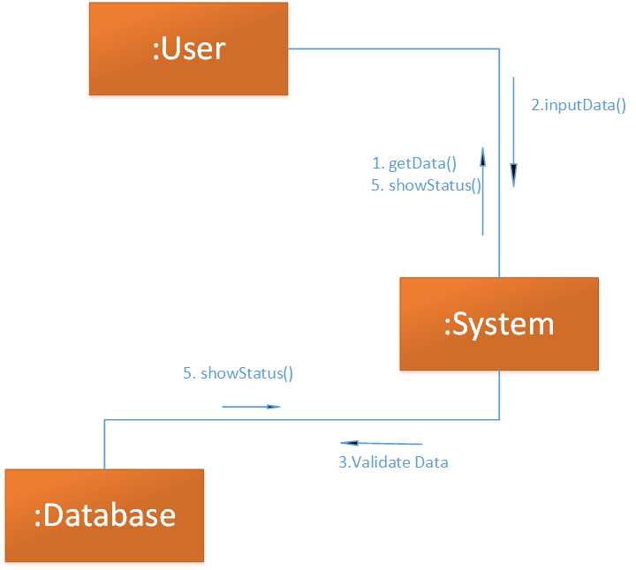

1.5.3 UC_Search_by_Location

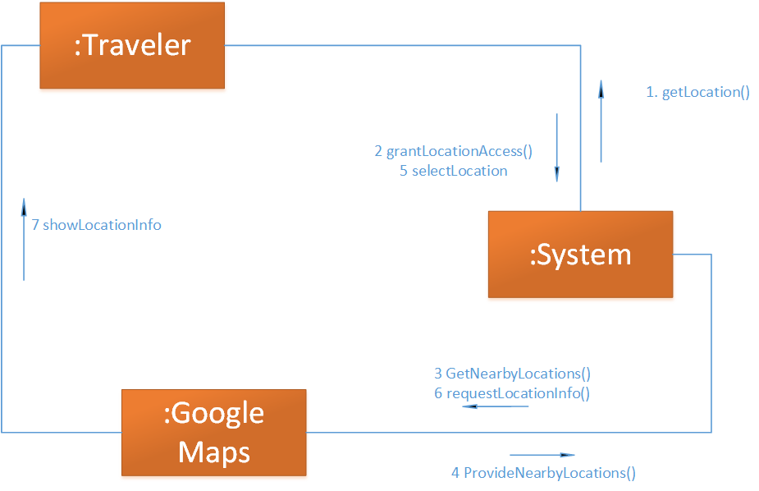

1.5.4 UC_Search_by_Destination

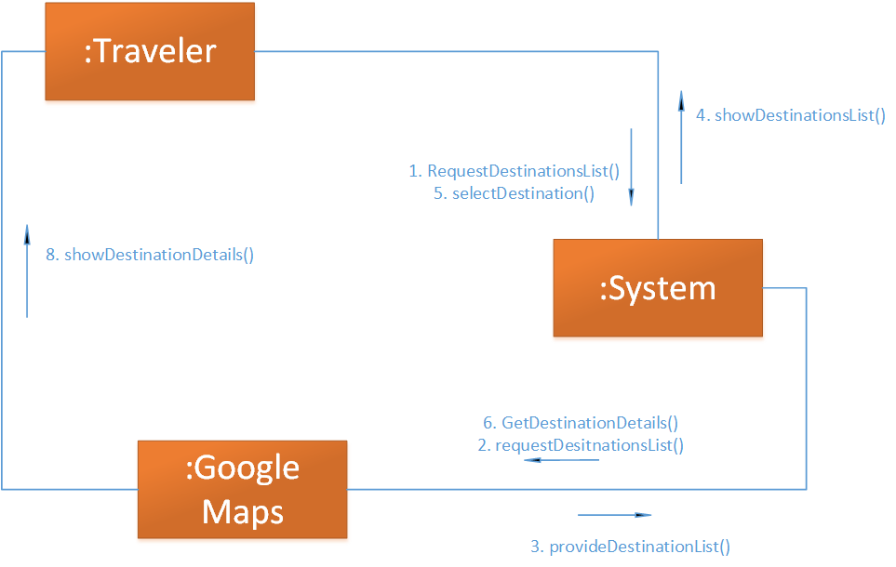

1.5.5 UC_Get_Directions

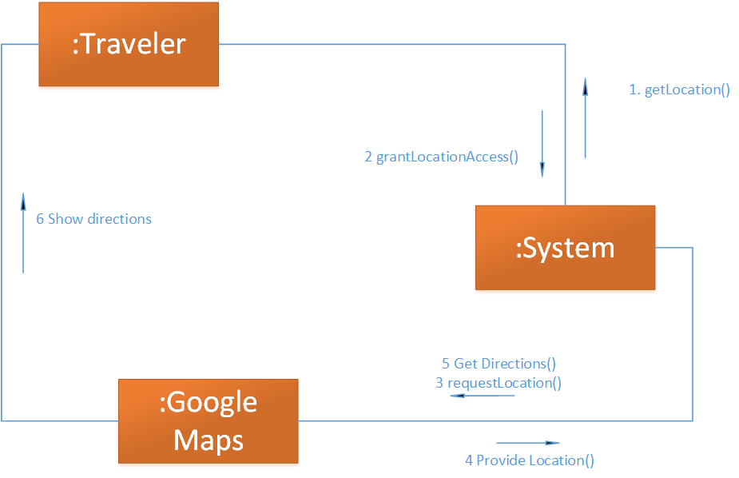

1.5.6 UC_Post_Rental_Ads

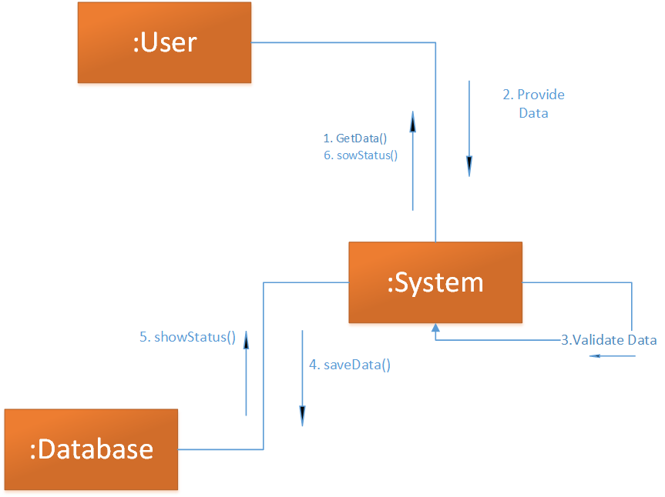

1.5.7 UC_Edit_Ads

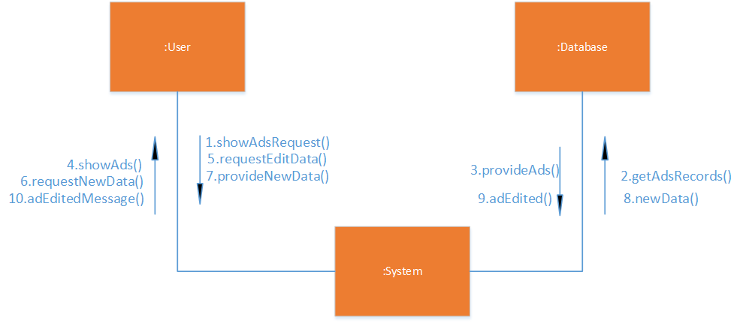

1.5.8 UC_Delete_Ads

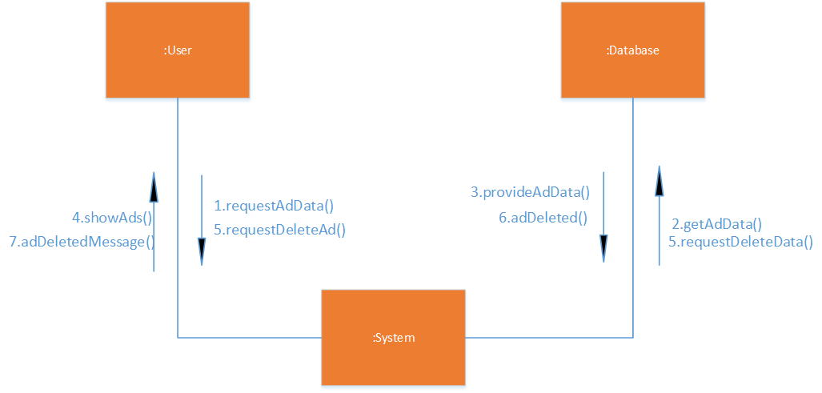

1.5.9 UC_Seacrh_Apartment

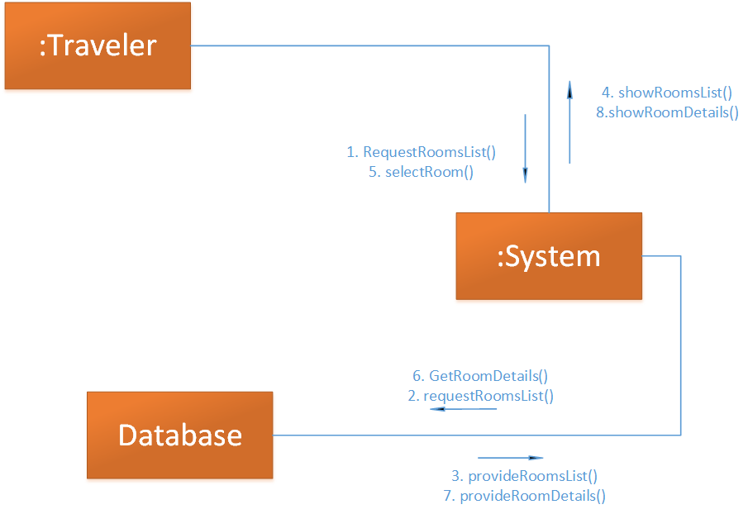

1.5.10 UC_Conversation

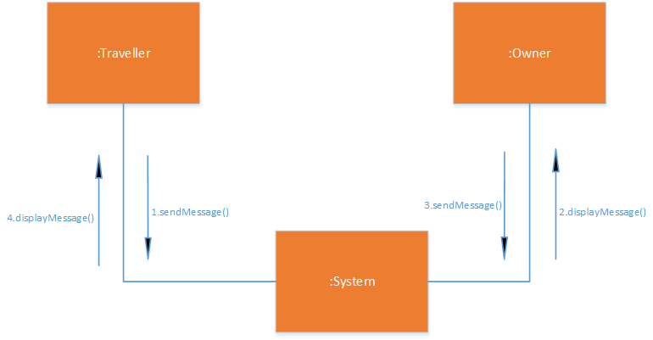

1.5.11 UC_Reserve_Apartment

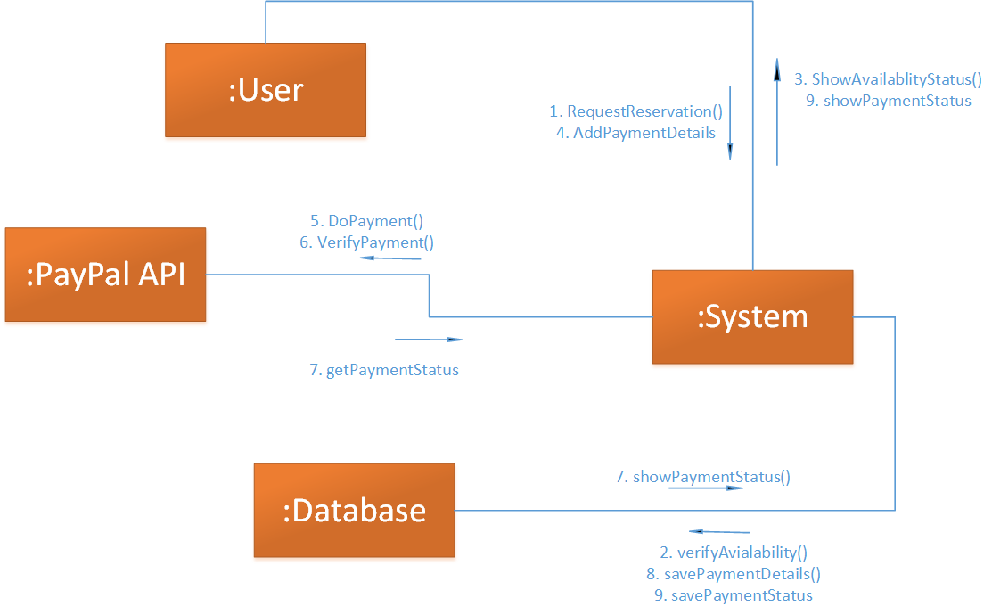

1.5.12 UC_Cancel_Reservation

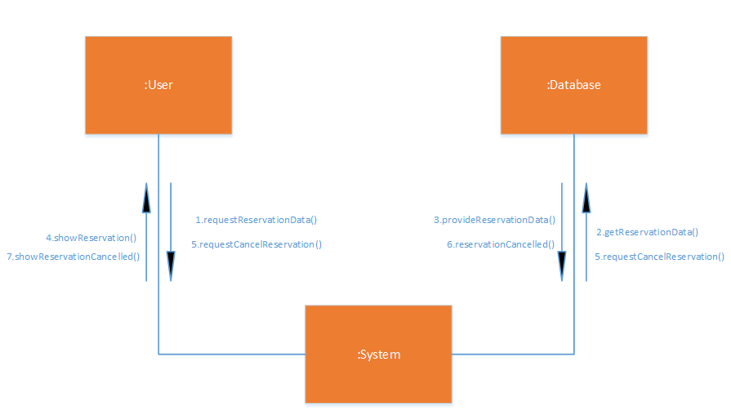

1.5.13 UC_Add _Review
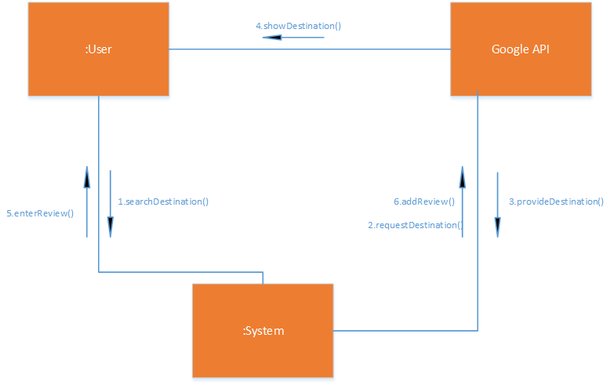

1.4.14 UC_Delete_Review

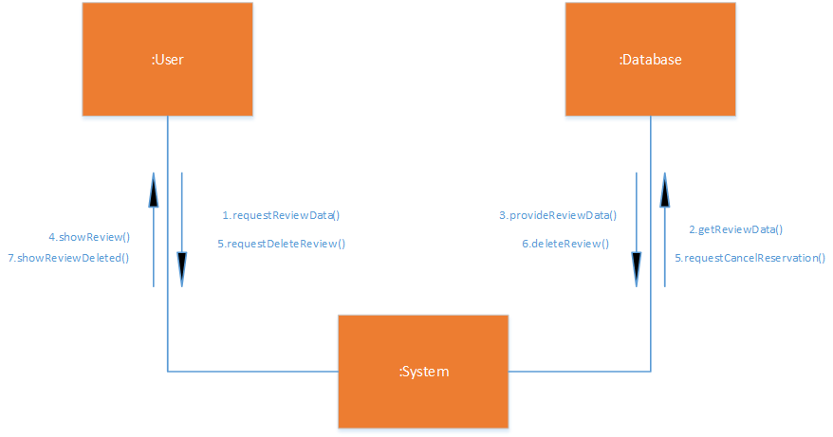

1.4.15 UC_Edit_Profile
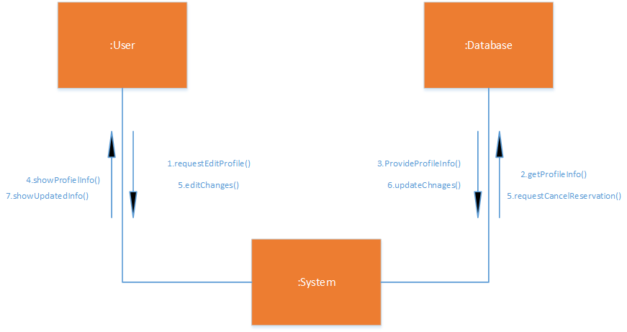

1.6 Operation Contracts

1.6.1 Contract CO1
Name: Registration
Responsibilities: successful registration of the user
Cross References: Use Cases: Registration
Exceptions: none
Preconditions: The user must have active internet connection
Postconditions: An account for the user will be created and the user will be directed to home screen.

1.6.2 Contract CO2
Name: Login
Responsibilities: successful login of the user
Cross References: Use Cases: Registration, Login
Exceptions: none
Preconditions: The user must have an account registered on the system and the user must have internet connection.
Postconditions: If the use case will be successful, the user will be logged into the system and directed to the home screen If not the system state will remain unchanged.

1.6.3 Contract CO3
Name: Add Reviews for Rooms
Responsibilities: user can successfully add reviews for the rooms
Cross References: Use Cases: Registration, Login,
Exceptions: none
Preconditions: The user must be logged in and user must have booked a room using our platform.
Postconditions: The review will be posted.

1.6.4 Contract CO4
Name: Add Reviews for Places
Responsibilities: user can successfully add reviews for the places he has visited.
Cross References: Use Cases: Registration, Login,
Exceptions: none
Preconditions: The user must be logged in.
Postconditions: The review will be posted.

1.6.5 Contract CO5
Name: Post Ads
Responsibilities: User (Landlord) can post an advertisement of the rentable room/apartment.
Cross References: Use Cases: Registration, Login,
Exceptions: none
Preconditions: The user must be logged in.
Postconditions: Advertisement will be posted successfully.

1.6.6 Contract CO6
Name: Search Rooms
Responsibilities: The user will be able to search the suitable room from the list of rooms available
Cross References: Use Cases: Registration, Login,
Exceptions: none
Preconditions: The user must be logged in.
Postconditions: User will get all the details of the advertisement

1.6.7 Contract CO7
Name: Edit Ads
Responsibilities: Landlords who added their post can switch availability i.e. they can label their advertisement as available or not available.
Cross References: Use Cases: Registration, Login,
Exceptions: none
Preconditions: Advertisement should be created, and the user must be logged in.
Postconditions: The advertisement status will be updated.

1.6.8 Contract CO8
Name: Delete Adds
Responsibilities: Landlords will be able to delete their advertisement from the portal when they desire
Cross References: Use Cases: Registration, Login,
Exceptions: none
Preconditions: Advertisement should be created, and the user must be logged in.
Postconditions: The advertisement will be deleted.

1.6.9 Contract CO9
Name: Search a Place: (By Location)
Responsibilities: User can find out all the nearby attractions places hotels restaurant just by turning ON his location services
Cross References: None
Exceptions: none
Preconditions: User should have a strong internet connection. User should turn on his location.
Postconditions: Application will successfully show all the nearby places getting location.

1.6.10 Contract CO10
Name: Search a Place: (By Destination)
Responsibilities: User can find all the prominent points of interest, and geographic locations and all the places just by entering a text string.
Cross References: None
Exceptions: none
Preconditions: User should have a strong internet connection. User should turn on his location.
Postconditions: Application will successfully show the details of the destination

1.6.11 Contract CO11
Name: Edit profile
Responsibilities: User can edit their profiles and update their personal information
Cross References: None
Exceptions: none
Preconditions: User must be logged in.
Postconditions: Application will successfully update the changes in profile information.

1.6.12 Contract CO12
Name: Start a Conversation
Responsibilities: User can start a conversation with the landlords of the place where he wants to live.
Cross References: Use Cases: Login, Registration
Exceptions: none
Preconditions: User should be booking a room.
Postconditions: Application will help in contacting with the place owners.

1.6.13 Contract CO13
Name: Reserve apartment
Responsibilities: User successfully pay for booking a room.
Cross References: Use Cases: Login, Registration
Exceptions: none
Preconditions: User should be booking a room.
Postconditions: Application will book a room for User.

1.6.14 Contract CO14
Name: Get Directions
Responsibilities: User successfully get direction for his selected place.
Cross References: Use Cases: Login, Registration, Search Place (By Location), Search place (By Destination)
Exceptions: none
Preconditions: The user must have internet connection.
Postconditions: The map will show all possible directions to the place.

1.6.15 Contract CO15
Name: Cancel Reservation
Responsibilities: User successfully cancel his/her reservation.
Cross References: Use Cases: Login, Registration
Exceptions: none
Preconditions: The user must have internet connection. The user must have made a reservation.
Postconditions: The reservation will be cancelled successfully.

1.7 Design Class Diagram
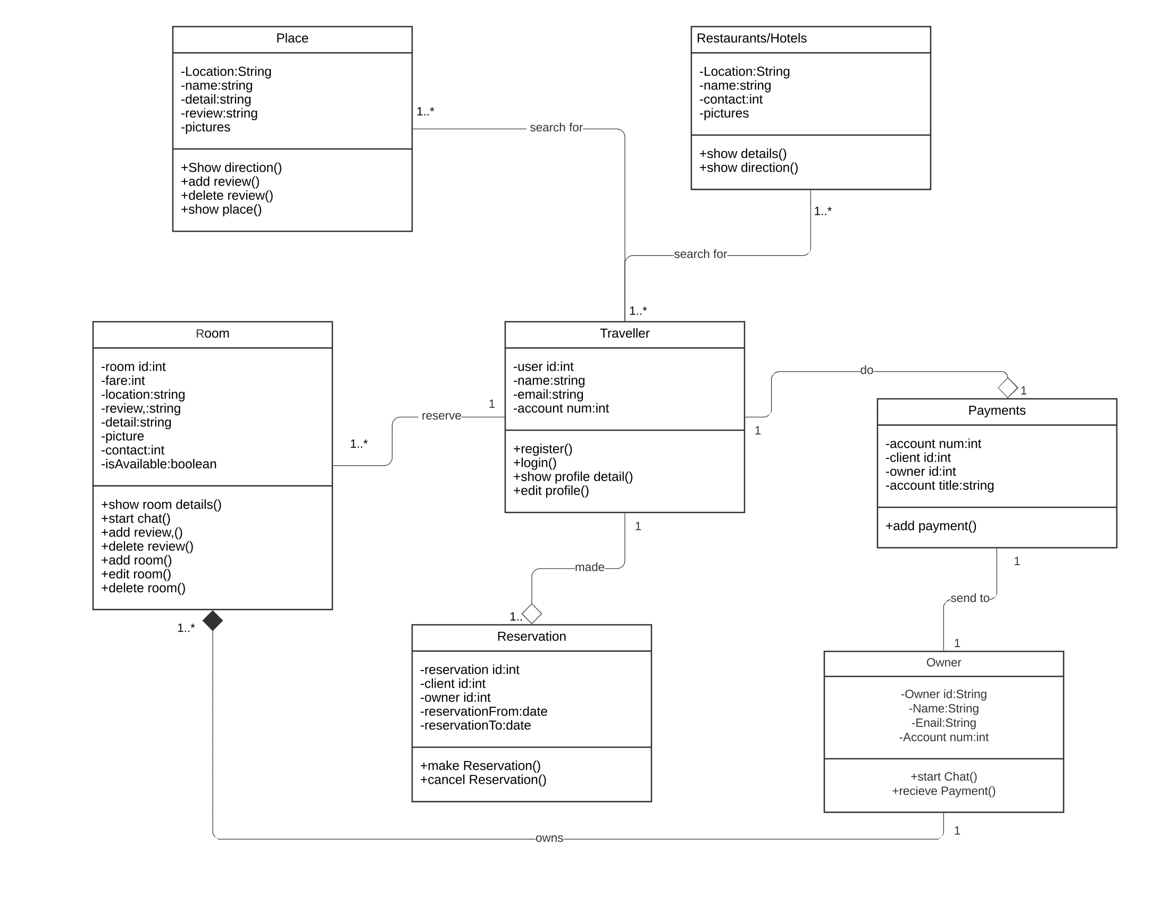

1.8 Data Model
